# Team 303

EGR 314

Abdul Husein, Chengbin Chen

1. 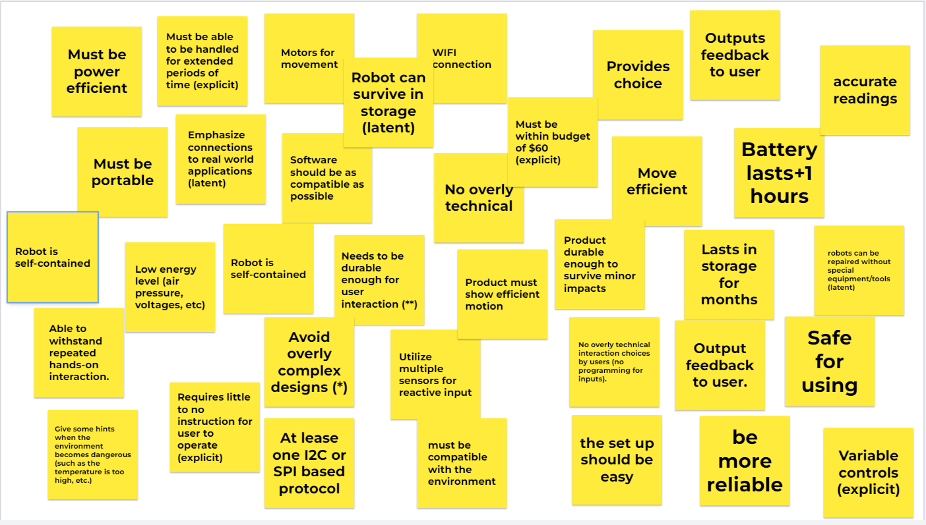
2. 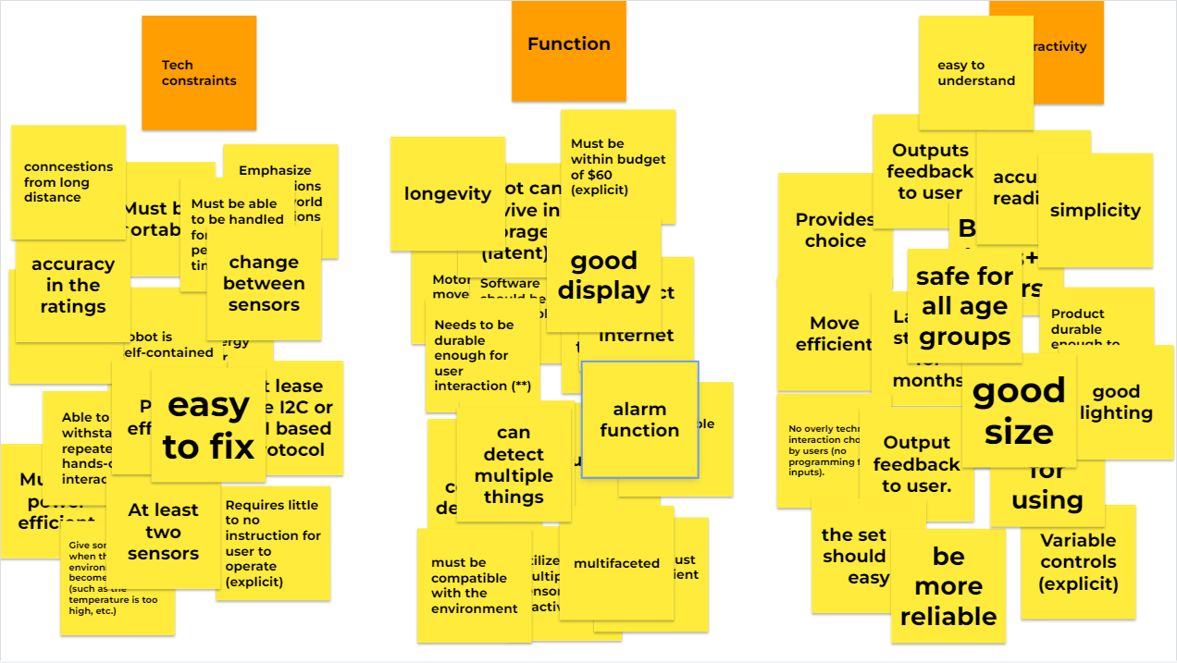
3. 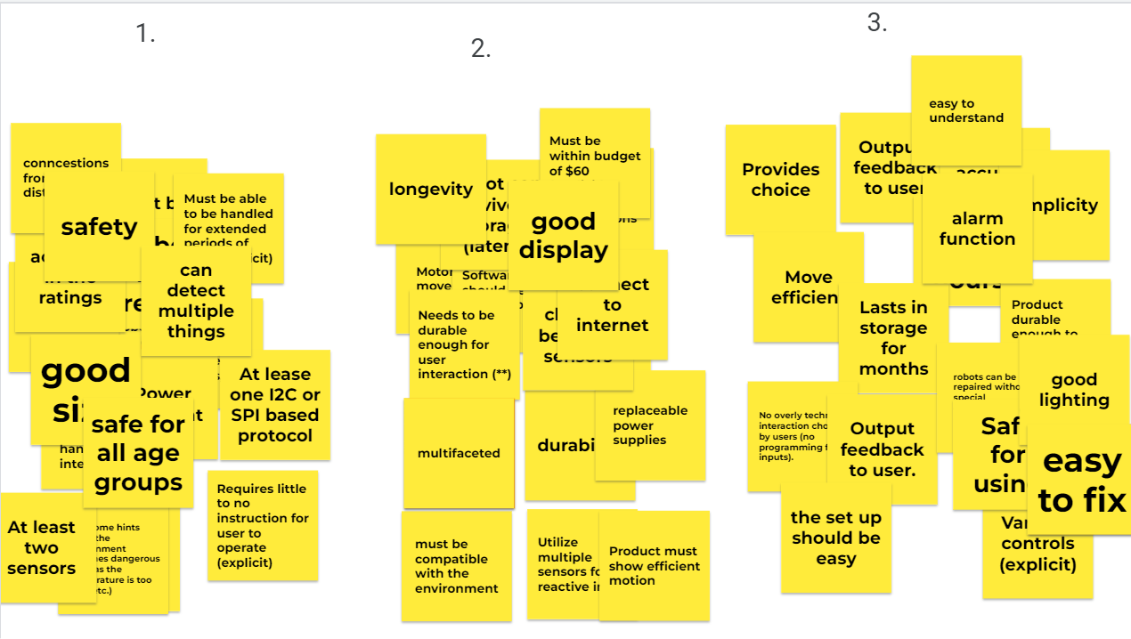

**List of User Needs:**

Our full list of needs is below:

1. **Safe for using (****)**
2. Low energy level (air pressure, voltages, etc)
3. Robot is self-contained
4. **Needs to be durable enough for user interaction (**)**
5. Product durable enough to survive minor impacts
6. Lasts in storage for months
7. Able to withstand repeated hands-on interaction.
8. **Avoid overly complex designs (*)**
9. Modular design
10. **WIFI connection(****)**
11. Motors included for movement
12. Variable controls
13. Utilize multiple sensors for reactive input
14. Must be repairable by basic replacement parts (within reason).
15. Products must be constructed from materials that are recognizable to users.
16. No overly technical interaction choices by users (no programming for inputs).
17. Output feedback to users.
18. Product battery lasts 1+ hrs
19. Provide choice to users
20. Replacement parts need to be within budget
21. Joints are able to be repaired without special tools
22. Interactive for users, not just something they watch from a distance
23. Emphasize connections to real world applications
24. **Multiple choices in how to measure surrounding environmental factors.(***)**
25. Multiple outcomes based on choices
26. Interesting for all ages
27. Product must be able to adapt to multiple environments for motion
28. Product must loosely follow a ratio between tactile, text, and audio outputs of 70/20/10
29. **Must be portable (****)**
30. Product demonstrates movement through unique mechanical properties/ design
31. Product must show efficient motion
32. **Products give some hints when the environment becomes dangerous (such as the temperature is too high, etc.) (**)**
33. Product rewards creativity in design
34. Product durable enough to survive minor impacts
35. Product have accurate readings
36. Software should be as compatible as possible
37. **At least one I2C or SPI based protocol (*****)**
38. Product must include an informational summary for facilitators to relate to users
39. Product appearance must be inviting to visitors and encourage investigation of its components.
40. The setup should be easy.

**Voice of the Customer**

**Selected Products**

## **Search #1**

## 

**Keywords: “Mobile Environmental Sensing Device”**

**Search Results Link:** [**https://www.amazon.com/s?k=Mobile+Environmental+Sensing+device&crid=HYJTPKCKGK4Y&sprefix=mobile+environmental+sensing+device%2Caps%2C126&ref=nb_sb_noss**](https://www.amazon.com/s?k=Mobile+Environmental+Sensing+device&crid=HYJTPKCKGK4Y&sprefix=mobile+environmental+sensing+device%2Caps%2C126&ref=nb_sb_noss)

## **Selected Products**

1. [**SensorPush**](https://www.amazon.com/SensorPush-HT-w-Thermometer-Hygrometer-Water-Resistant/dp/B08PKWPKM2/ref=sr_1_16?crid=HYJTPKCKGK4Y&keywords=Mobile+Environmental+Sensing+device&qid=1673925044&sprefix=mobile+environmental+sensing+device%2Caps%2C126&sr=8-16)

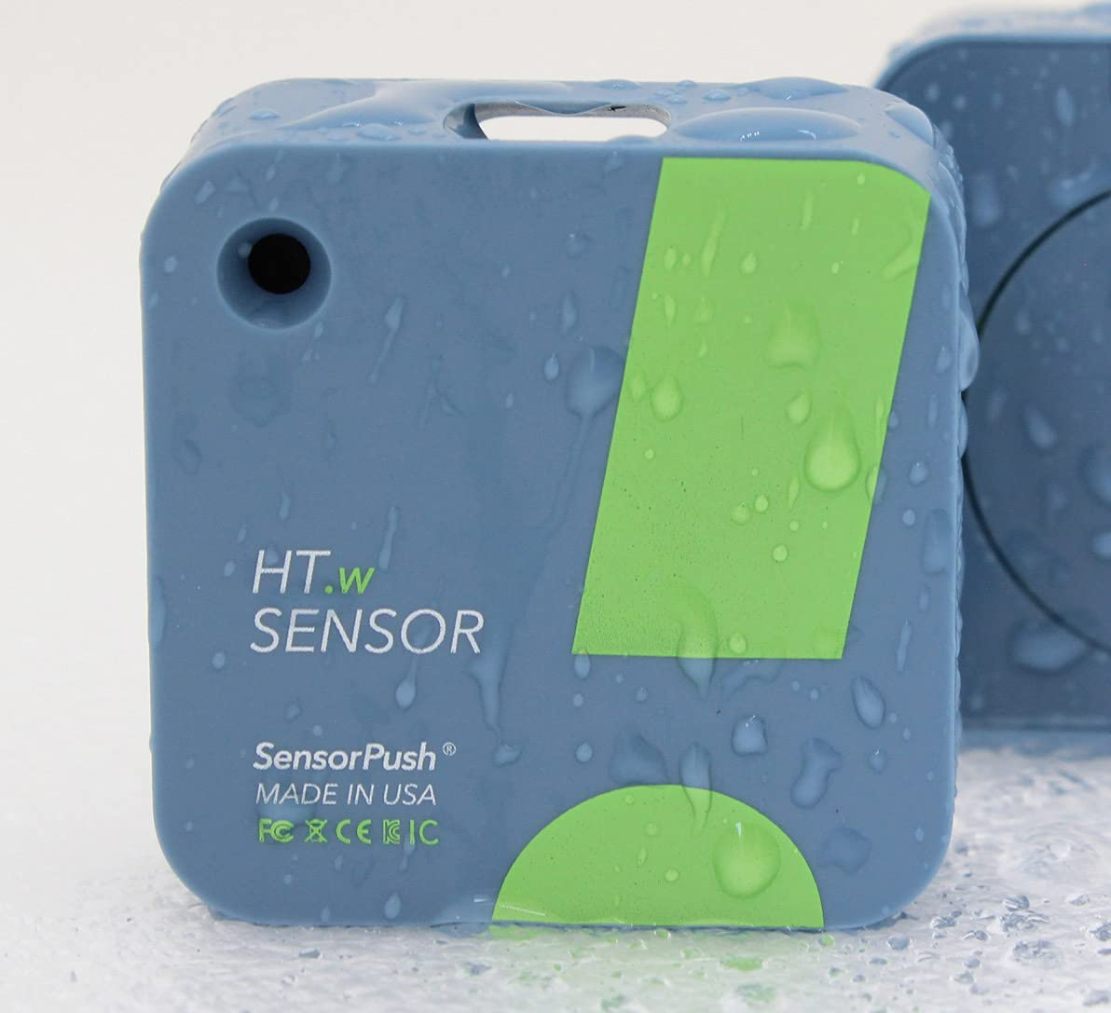

* **Price:** $69.99
* **Vendor:** Amazon
* **Description:** The SensorPush HT.w Water-Resistant Indoor/Outdoor Humidity / Temperature Smart Sensor with Alerts.Accurate: Premium sensing component with accuracy of ±2%RH, ±0.2°C / 0.36°F.Durable: Water-resistant splash-proof and weatherproof design protects sensor from rain and dust. Flexible: Use just the sensor and your phone via Bluetooth or add a SensorPush G1 WiFi Gateway (sold separately) for data and alerts via the Internet.Powerful: Line of sight Bluetooth range of 325 feet keeps you up to date, even on the other side of your home. Easy one-time setup with our beautifully designed, free app (iOS or Android).

**Product Reviews:**

**Positive Comments**

| **Customer Comments** | **Emphasized Customer Need** |
| --- | --- |
| “However I'm sure it functions just as well and it's not like you carry it in your hand to use it. It's more made to sit somewhere so surface material doesn't really matter as long as it's durable. But still, I liked the feel of the other plastic surface on the old one. Was a bit of a softer feeling. Functionally no issues to report though. Great little sensor. Comes in handy a lot.” | * Easy to place (explicit) * Can come in handy in many scenarios. (explicit) |
| “Go ahead and buy the gateway so you can monitor them from anywhere and see them on your computer via WiFi vs. just bluetooth.They have configurable alarm setpoints for both low and high temp and RH with email alerts.The real value of these is the history and the alarms. You can view the temps and RH history for days and weeks. The data are also downloadable via .csv files. ” | * With alarm function.(explicit) * You can monitor it from anywhere.(explicit) |
| “ I really like that battery voltage, signal strength, etc. are all reported.” | * The use of the product is simple and easy to understand.(explicit) |

**Negative Comments**

| **Customer Comments** | **Emphasized Customer Need** |
| --- | --- |
| “It would be nice to be able to set a condition that, instead of throwing an alarm anytime the temperature exceeds X for one sample, requires that the temperature be greater than X for some user-specified length of time. This would cut down on false positive temperature alarms.” | * The product lacks the ability to allow users to personalize it. (explicit) |
| “Worked fine for several weeks, then became wildly inaccurate. Threw it away and bought a different brand that works OK.” | * Products should have a longer lifespan and maintain accuracy. (explicit) |
| “My batteries DIED after less than a year. Attempted to replace and zippo, nothing. A waste of $50 per sensor.....Piece of junk! ” | * Product must be power efficient(explicit) * Product power supplies need to be replaceable. (explicit) |

**Search #2**

**Keywords : “Temperature Sensor”**

**Search Result Link:** [**https://www.amazon.com/s?k=temperature+sensor&crid=2W2PN9GJSFVI7&sprefix=Temperature+%2Caps%2C180&ref=nb_sb_ss_ts-doa-p_3_12**](https://www.amazon.com/s?k=temperature+sensor&crid=2W2PN9GJSFVI7&sprefix=Temperature+%2Caps%2C180&ref=nb_sb_ss_ts-doa-p_3_12)

**Selected Products**

1. [**Nest Sensor**](https://www.amazon.com/Nest-T5000SF-Sensor-Thermostat/dp/B07DGWXCNN/ref=sr_1_7?crid=2W2PN9GJSFVI7&keywords=temperature%2Bsensor&qid=1674004907&sprefix=Temperature%2B%2Caps%2C180&sr=8-7&th=1)



* Price :$39
* Vendor: Amazon
* Description: Works with compatible Nest thermostats.Control your Nest sensor in the Nest app.The Nest Temperature Sensor is easy to set up; just hang it on the wall or place it on a shelf.The Nest sensor runs on batteries so it works in most homes; batteries can last up to 2 years.Add up to 6 sensors for each compatible Nest thermostat in your home.Long battery life - Works on CR2 3V lithium battery (included) with up to 2-year lifetime. | Connectivity : Wireless, Bluetooth Low Energy connection. | Up to 50 feet range. Allows easy placement.

**Product Reviews:**

**Positive Comments**

| **Customer Comments** | **Emphasized Customer Need** |
| --- | --- |
| We have a large home with the thermostat some distance, two rooms, and a hallway separated from the bedroom which has always been too cold or too hot. We tried closing some vents, but that didn't help. We thought a smart thermostat might help, but it didn't. We considered relocating the thermostat to the bedroom, which would be a difficult and possibly expensive project. Then I thought about looking for a remote, wireless thermostat sensor. Found this one on Amazon and ordered it. The installation was VERY easy. Programing was simple. It works like a charm, and saved a lot of money over other alternatives. Highly recommended. | * Works in separate rooms (explicit) |
| Installed this temp sensor upstairs in the master bedroom. Now the Nest can be programmed to use the upstairs sensor at night when we are upstairs and use the main thermostat during the day when we are downstairs. We can also manually change the which sensor to use anytime if we decide to hang out upstairs during the day. This is great for the winter months when the heater tends to create a temperature difference between up and downstairs. | * Manually able to change between different thermostats. |
| I think it was harder to take the shrink wrap off than get the sensor set up. Scanned a QR code from the sensor, pulled a tab to activate the battery. Hit next a few times to let the sensor talk to the main unit, give the sensor a room name, bam, the temperature feedback is coming from the back room instead of the hallway! Very slick. | * Easy to set up (explicit) |

**Negative Comments**

| **Customer Comments** | **Emphasized Customer Need** |
| --- | --- |
| “The battery lasted about 1.5-2 months, once the battery died so did the device. I haven't had any luck connecting the device after having replaced the batteries. I've tried 3 separate CR2 battery brands and no luck. Not worth it if i have to buy a new one every 2 months. Pass.” | * Product accessories should be easily replaceable.(explicit) |
| “Some people where saying that you can get the avg. temp from the base Nest unit and one of these puck devices, which is simply not the case (at least not anymore through the app). You are only give the option to choose what temp input (Nest base or this puck) to set as the current house temp.” | * The product temperature monitoring range should be large.(explicit) |
|  |  |

## 

## **Search #3**

**Keywords: mobile temperature sensor**

**Search Results Link:** [**https://www.amazon.com/Wireless-Temperature-Humidity-Monitoring-Smartphone/dp/B08JP39RLP/ref=sr_1_3?crid=1LJAYCFML0B9B&keywords=mobile+temperature+sensor&qid=1674005078&sprefix=mobile+temperature+sensor%2Caps%2C201&sr=8-3&ufe=app_do%3Aamzn1.fos.006c50ae-5d4c-4777-9bc0-4513d670b6bc**](https://www.amazon.com/Wireless-Temperature-Humidity-Monitoring-Smartphone/dp/B08JP39RLP/ref=sr_1_3?crid=1LJAYCFML0B9B&keywords=mobile+temperature+sensor&qid=1674005078&sprefix=mobile+temperature+sensor%2Caps%2C201&sr=8-3&ufe=app_do%3Aamzn1.fos.006c50ae-5d4c-4777-9bc0-4513d670b6bc)

## **Selected Products:**

# 

3. Smart wireless temperature sensor

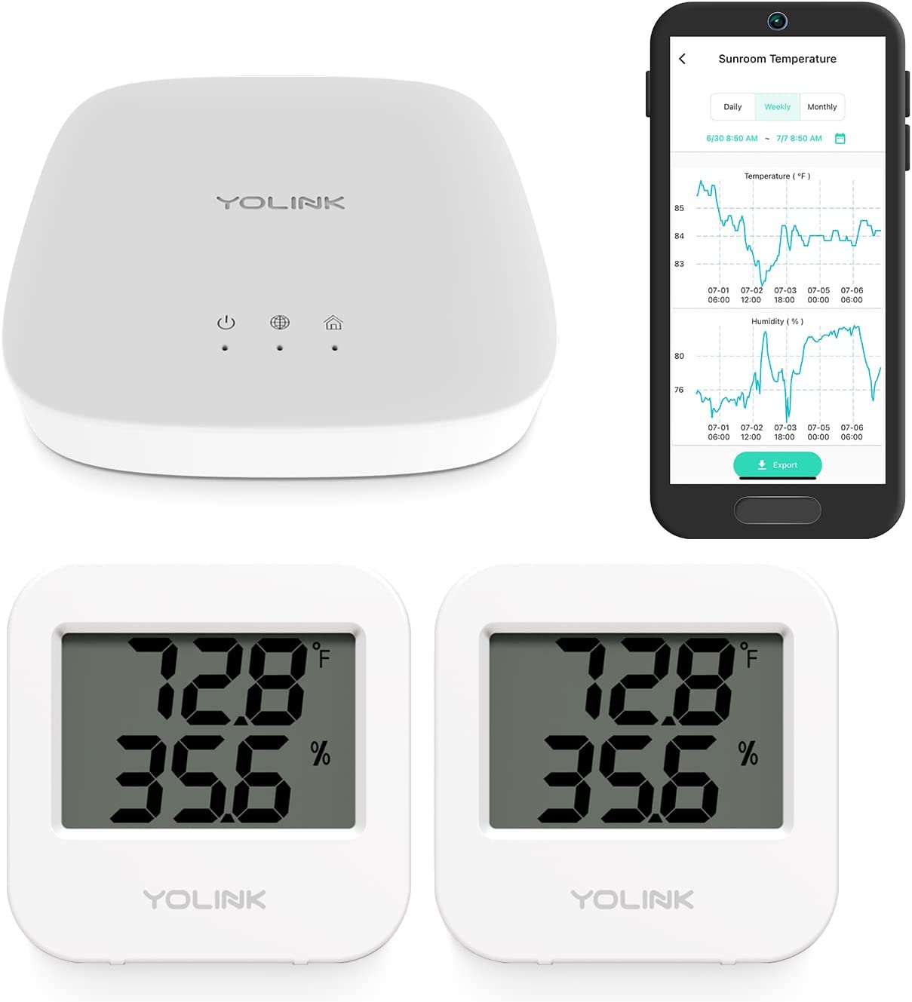

* Price: $69.99
* Vendor: Amazon
* Description: DON'T TRY THIS WITH WiFi! Our unique LoRa-based sensors are different from WiFi, Zigbee, Z-Wave and most other wireless smart sensors in that they are extreme long-range (up to 1/4 mile open-air), low-power (years between battery changes), and work outdoors*, on other floors, and even in a metal box (like a fridge or mailbox)!

**Product Reviews:**

#### **Positive Comments**

| Voice of the Customer | Restated Customer Need |
| --- | --- |
| We purchased this to alert us to power loss or freezer failure. Our two sensors are located one in each of our freezers. The hub hooked up via ethernet. Easy to scan hub and both sensors into the app on phones and set up alerts. The few questions I had were answered quickly by customer support via email so we have been happy with this purchase and it is doing what we need it to. We had a power outage and received notification on our app and via SMS so we could monitor and respond. | * Easy to set up (explicit) * Works well in power outages (explicit) |
| I got these for a deep freeze out in my detached garage. This setup quickly and without fuss. It's very accurate and has an impressive range. It was easy to setup custom parameters to alert me to extreme temperature changes sent directly to my phone. | * Very accurate ratings and calculations (explicit) * Sends alert through the app (explicit) |
| One is monitoring vegetable storage in the garage, one is in the chicken coop, both places where we need temperature and humidity monitored. We have the app on two phones, base station is in the middle of the house. Great buy. | * Monitors Humidity (explicit) * Has connection even from long distances(Latent) |

#### 

#### 

#### 

#### 

#### 

#### 

#### **Negative Comments**

#### 

| The sensors are side by side and do not read the same. One sensor will not read at all. I even went through product support at Amazon until my call dropped. I went through the same steps repeatedly trying to get it to work. Very disappointed that is doesn't work | * Defective sensors (explicit) * Not good display (explicit) |
| --- | --- |
| 2 sensors out of 10 keep draining batteries,  I need to replaced the batteries 2 times each month. | * Drains the batteries to quickly (explicit) |
| The temperature reading is NOT ACCURATE!! Off by 14 degrees. Amazon refused to return the product because we missed the return window by a couple days! Total waste of money! | * Inaccurate sensors (explicit) |

### 

**Search #4**

**Keywords: Mobile Weather station**

**Search Results Link:** <https://www.amazon.com/Newentor-Wireless-Thermometer-Adjustable-Backlight/dp/B0836CM7KY/ref=sr_1_7?keywords=mobile+weather+station&qid=1674006434&s=home-garden&sr=1-7>

## **Selected Products:**

## 

* Price: $38.24
* Vendor: Amazon
* Description: [7.5" LCD Screen Weather Stations] Newentor temperature and humidity monitor with large color display, which shows comprehensive information: inside outside temperature humidity(max/min, hi/lo), customizable alerts, time/date, alarm clock/snooze, weather forecast (next 8-24 hrs) moon phase, barometric pressure.
* [3 Channels Home Weather Stations Wireless Indoor Outdoor] Wireless temperature forecast station supports up to 3 remote sensors to monitor inside outside temperature & humidity of multiple locations. The digital weather station contains one remote sensor.
* [Wireless Color Forecast Station] The weather forecast station calculates the weather forecast for the next 12-24 hours, 7 to 10 days calibration ensures an accurate personal forecast for your location.
* [Wireless Weather Station with Atomic Time and Date] Atomic alarm clock weather station can be used not only as a wireless indoor outdoor thermometer but also as an atomic clock with dual alarms.
* [Two Power Modes & Brightness Adjustable Backlight] The screen can be set to always-on or power saving mode when the adapter is plugged in.

**Product Reviews**

**Positive Comments**

| **Customer Comments** | **Emphasized Customer Need** |
| --- | --- |
| I was looking for a new weather station when my old one stopped working. I came across this one on Amazon and took a chance on it. The features that I really liked on this device is that it has a large color display, the display can be dimmed, and that the device can be used with either batteries or the supplied ac cord. I also had a really good experience with customer service. I noticed that the inside temperature display was stuck on the same temperature. So I emailed customer service and they responded very quickly about how to solve the issue by resetting the device. They also reached out the next day to see if I got the unit fixed. The unit worked great after the reset and I have not had any issues with the unit thus far. I would definitely recommend this product to my friends and family and will keep this company in mind for future purchases. | * Multiple power sources (explicit) |
| This is a great weather station. You can see it from a distance -big numbers, moon phase, indoor-outdoor temps with humidity. I had to move it and when I plugged it in again, the indoor temp wouldn't register correctly. I contacted the company via email, they got back to me within a day. They told me they stand behind their products and this item has a one-year warranty. They suggested I erase the memory, unplug the unit, take the batteries out and let it set for approx. 1 hour. I did that and when I put the batteries in and plugged it in, it worked perfectly. The next day they sent me another email since I didn't get back to them and said they are concerned about my device and wanted to know if it was now working or if they would need to send me a new one. I sent them an email noting that what they suggested to try and fix it worked perfectly and I was happy. This was a great customer service experience and I would purchase other items from this company based on the way this was handled. | * Good display screen |
| You can see it from across the room, to get a quick glance on temps. Once I studied the manual it was set up easily. I had a few minor blips at first but glad I got it. It has worked out great in the current blizzard temps. Let's you know how to dress if you go out. Will be getting other sensors to connect to monitor temps in other parts of house and | * Durable (explicit) |

**Negative Comments**

| **Customer Comments** | **Emphasized Customer Need** |
| --- | --- |
| I bought the very attractive Weather Station 9 months ago. The outdoor weather is accurate, indoor temperature NEVER changes: it always reads 74.2 degrees. Periodically the entire screen goes blank for a brief time, then comes back on. (Only once did it remain blank for days, but unplugging it and plugging it back in brought the screen back.). Disappointed that it is unreliable, I really liked it. Time to look for something else that is accurate and dependable! | * Inaccurate (explicit) |
| After several attempts I still can’t get the remote sensor to remain connected for more than five minutes to the weather station. I contacted the seller for assistance, requesting an reply. I still have not heard from them. | * Trouble connecting remotely (explicit) |
| I can't understand why this Newentor Weather Station has received any favorable reviews. The user manual is difficult to read and understand; it only shows daily high and low temperatures after pressing several buttons and the barometric pressure it consistently reports (25.81 inches of mercury) doesn't occur anywhere on earth! For all of the above reasons, I'm returning the unit and searchinging for something better. | * Difficult to use (explicit) |

**Search #5**

**Keywords: Mobile Weather Station**

**Search Results Link:** <https://www.amazon.com/dp/B08M598J5B/ref=redir_mobile_desktop?_encoding=UTF8&aaxitk=b6c6bcf98838bb9defb874b764aacc36&content-id=amzn1.sym.7e9cd8c2-888c-46c4-82d2-714b2b703021%3Aamzn1.sym.7e9cd8c2-888c-46c4-82d2-714b2b703021&hsa_cr_id=6443719840901&pd_rd_plhdr=t&pd_rd_r=e1afccc1-4d8c-42f0-81e1-648b91a75943&pd_rd_w=RxUr4&pd_rd_wg=euOR8&qid=1674007358&ref_=sbx_be_s_sparkle_lsi4d_asin_0_title&sr=1-1-9e67e56a-6f64-441f-a281-df67fc737124&th=1>

## **Selected Product:**

**5.**

* Price: $159.99
* Vendor: Amazon
* Description: 7-IN-1 PROFESSIONAL WEATHER STATION | All-in-One Monitoring System Provides Real-Time Weather & Precipitation Data Based on Conditions in Your Own Home & Backyard! | Get the Most Precise Temperature, Humidity, Wind, Rain, UV & Solar & Other Environmental Readings—More Accurate Than Any National Weather Station
* EASY-MOUNT BACKYARD SENSOR | Position Unit Outside on a Pole or Railing [Up to 492 Feet Away], Then View Personalized Up-to-the-Second Weather Data from Inside! | Complete Station Includes Wind Vane, Anemometer, Temp/Humidity Sensors, Rain Collector, UV and Solar Sensors, Level & Antenna | Runs for Up to 2.5 Years with the Integrated Solar Panel and 3 AA Batteries (batteries not included) | Includes an Intoor Temp/Humidity Sensor, Connect up to 7 sensors
* FULL-COLOR INDOOR LED DISPLAY | Tabletop or Bedside Console Shows Current Wind Speed & Direction, Outdoor & Indoor Temp/Humidity, Barometric Pressure, Rainfall Rate, UV & Solar Exposure, Weather Index, 12/24-Hour Forecasts, Sunrise & Sunset, Moon Phase, Day/Date & More | Includes Dimmable Backlight & Alarm with Ice & Other Extreme Weather Notifications
* WI-FI SYNCS WITH LIVE WEATHER SERVERS | Smart Model Automatically Transmits Data Via Wi-Fi for Web & Mobile App Integration | Connect to Weather Underground & Weathercloud, Track Current Data, View Historical Trends Up to 500 Days Prior, Analyze Graphs & More | See Everything Right on Your Smartphone, PC or Tablet
* STRESS-FREE SETUP & OPERATION | Set Includes Easy Step-By-Step Instructions for Mounting Outdoor Weather Station | Indoor Console Supports Imperial/Metric Units & Features Simple Touch Button Controls for Viewing Various Data Screens & Settings Options

**Product Reviews**

**Positive Comments**

| **Customer Comments** | **Emphasized Customer Need** |
| --- | --- |
| I have only had this a few days but it was relatively easy to set up. The manual wasn’t real thorough and I am not real tech savvy so part of the electronics was a little aggravating. Once I got it set up all the numbers came on in a few seconds. Everything seems to be accurate and so far I am pleased. | * Easy to set up (explicit) * Accurate (explicit) |
| Very impressed with the operation and apparent accuracy. The display can easily be seen across the room. Connection to wifi and Wunderground Weather was not too difficult and is a great asset for accumulating past data. | * Great Display (explicit) |
| Easy to install. Put on top of my antenna mast pole. Working with in minutes. I can add up to 8 temperature, humidity sensors. I have one in my green house, garage, basement and back room. Out of the 3 previous weather station this is the best so far. | * Can add multiple sensors (explicit) |

**Negative Comments**

| **Customer Comments** | **Emphasized Customer Need** |
| --- | --- |
| I’m not a big reviewer on Amazon but I really felt compelled to let folks who may be shopping for a weather station know to pass on this one! I bought this and while installing it realized that the base station doesn’t allow WiFi access or have battery backup like most of the others. OK I can deal with those shortcomings. I after using it for a while I started to notice that the at times wind speed didn’t seem correct. Being by the beach, I initially thought perhaps there was interference with other houses close by so I moved the sensor to another spot that’s certainly out of the way. Same results, occasional low wind speed measurements. I finally called Logia and was given instructions on how to reset the sensor, and told that the unit is still under warranty and if this doesn’t work Logia will send me another one. Perfect. I waited for a nice enough day to get on the roof and follow the procedure he gave me then waited to see if the accuracy was improved. No such luck. Same issue with low wind speeds. When I called Logia back, the new guy I spoke with was very nice but told me he saw where I had called and the guy I spoke with previously was no longer with the company. He further told me that Logia is aware the wind speed sensor is not accurate, and that my warranty has now expired so they can’t help me. He then told me to have a great new year and hung up.. it was frustrating but also pretty comical. How this company is still in business surprises me..  Bottom line, there are many other similar priced weather stations that have WiFi and battery backup, AND provide accurate data! | * Inaccurate sensors (explicit) |
| Bought this the end of August. It is now the end of November and the bearings in the anemometer are already shot. I realize Wyoming has serious wind but come on, the bearings should last longer than three months. The thing barely rotates at 1.5 mph when the wind is gusting at 35 mph. Great when it was working but a waste of money in the end. | * Not durable enough (latent) |
| 1. Temperature & humidity readings were inaccurate by a long way.  2. Trying to connect this thing to the internet was very difficult, indeed, impossible for me. I spent 1.5 hours trying to do it & I'm pretty computer literate but this takes someone with an IT level understanding of their router to make it work.  3. I returned the item & received a notice that the return was complete & my refund was issued but I never received credit on my Amazon credit card.  4. I have sent 3 messages over the period of about 8 days explaining the problem & no one has answered me.  10/19/21 Update: I did receive a credit quickly in the form of a gift card which I didn't notice, so I withdraw items 3 & 4. | * Difficult to connect to the internet |

**Product Requirements Document**

**Arizona State University**

**EGR 314**

Project Manager: Abdul Husein, Zhengbin Chen

Date of Creation: 01/17/2023

Version 1

**Introduction**

This semester we will be producing and creating a system that reads the environment using multiple sensors and acutation. We will also need to broadcast it to the internet over WiFi.

**Objectives**

We will be creating a mobile weather station using at least 2 separate sensors. The sensors will capture multiple environmental conditions and effects. We will also need a SPI or I2C motor controller. At the end of the semester we will be presenting the results at the innovation showcase.

**Stakeholders**

**Target group.** People who want to monitor the weather.

**Target purchaser***.* People who want to be able to tell the weather using a mobile weather station

**Customer service.**.aims to assist in case of malfunction or errors.

**Marketing & Sales division**.. Aims to sell it to people and showcase user experience.

**Senior Management***.* Aims to ensure that the product is being manufactured and managed well.

**Retailers**. Stores that sell outdoor material and general convenience.

**Use Cases**

**User Story #1: Maria**

Maria is a customer who grows plants in their backyard. They want a mobile weather station to detect the temperature outside so her plants do not get affected by the temperature.

**User Story #2: William**

William is a father with two children. He wants to give his children an intellectual education of engineers at an early stage. He needs a robot that can attract children's attention with interesting performances, and at the same time has monitoring functions (such as temperature, humidity, wind, atmospheric pressure, etc.)

**Aspects**

**1.** **Product Design**

* 1.1 The product’s motion will not be dependent of the surface that it is moving across (P8)
* 1.2 The design will feature low cost and recycled materials for most of the design (P7)
* 1.3 The product will be modifiable by users without specialized tools (P4)
* 1.4 The product will be durable enough to survive minor impacts and mishandling (P7)
* 1.5 The product will utilize the Microchip microcontroller as the main controller for sensor inputs and motors (P10)
* 1.6 The product will adapt to two (2) sensor inputs connected to the microcontroller (P10)
* 1.7 The product will not be larger than a 1’ by 1’ footprint (P9)
* 1.8 The product will connect to real world application intrinsically through it's design (P9)
* 1.9 The product should be portable. (P8)

**2.** **Functionality**

* 2.1 The product will feature a rechargeable battery life of over one (1) hour （P10）
* 2.2 Product should show a various range of motor functions within the design. （P8）

**3.**  **Interactivity**

* 3.1 Product should provide more than one action for interacting with visitors. （P10）
* 3.2 Product should have multiple choices in the interaction process for users. （P10）
* 3.3 Product should have multiple outcomes based on previous choices.（P10）
* 3.4 Product needs to provide users with adequate feedback when interacted with.（P7）

**4 .**  **Adaptive Intelligence**

* The product can give prompts according to changes in the environment. (P10)
* Products can move based on sensor input.（P8）

**5.**  **Customization**

* 5.1 Product should be modular in design, so as to allow users a more unique experience. （P6）
* 5.2 Product should allow users to change the design in some way through adjusting limbs or other widgets.（P6）

**6.**  **Manufacturing**

* 6.1 The product will not go above a budget of $240 USD ($60 per team member)（P10）
* 6.2 The product shall be designed to consist of the minimum possible amount of parts. (P8)
* 6.3 Parts should be easily separable for maintenance by service personnel（P7）

**7.**  **Safety Regulations**

* .7.1 The product must operate at low energy levels.（P10）
* 7.2 The product should not have rough/serrated edges or unsafe wiring which can harm users.（P8）
* 7.3 The product must be made of safe materials.（P8）

**Open Questions**

* Can the product be designed with only recyclable materials in mind?
* Can we incorporate in the design the ability to use a mobile phone to remotely control the movement of the product?
* What are some examples of modules that can be interchanged within our design?
* Does our actuator have to be connected to the sensor? Or can it only be connected with the microcontroller?

**Milestones**

Concept presentation: 01/23/23

Design presentation: 02/16/23

Design freeze: 04/23/23

Planned release: 04/28/23